**Introduction to Graph Theory**

A Graph is a simple yet incredibly useful concept, which has found many applications in virtually every branch of math and computer science. We use Graph applications daily, just to name a few cellphones network, GPS navigation, Internet search queries.

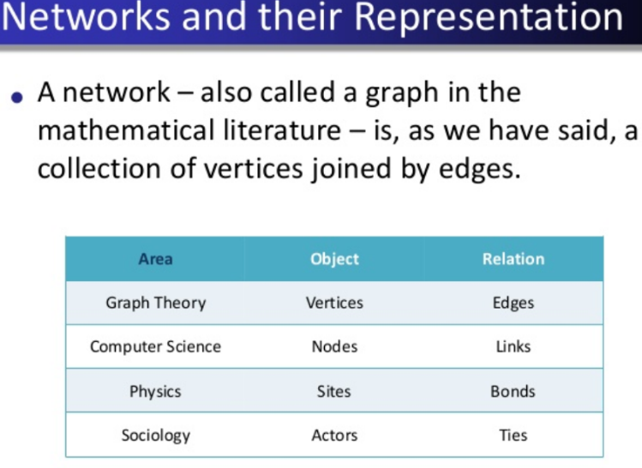

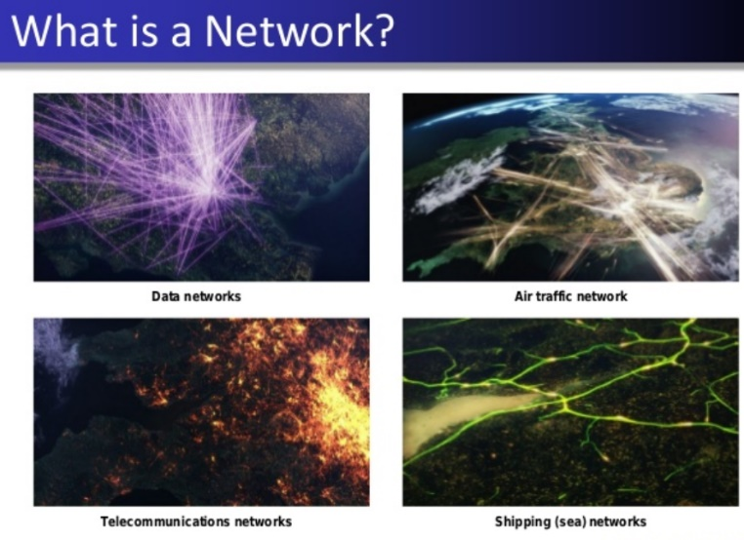

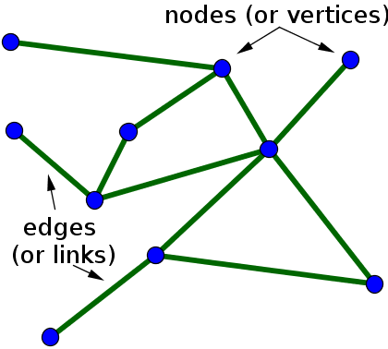

In mathematics, networks are often referred to as [graphs](https://mathinsight.org/definition/graph), and the area of mathematics concerning the study of graphs is called *graph theory*. Unfortunately, the term *graph* can also refer to a [graph of a function](https://mathinsight.org/function_graph_definition), but we won't use that use of the term when talking about networks. Here, we'll use the terms *network* and *graph* interchangeably.

Networks can represent all sorts of systems in the real world. For example, one could describe the Internet as a network where the nodes are computers or other devices and the edges are physical (or wireless, even) connections between the devices. The World Wide Web is a huge network where the pages are nodes and links are the edges. Other examples include social networks of acquaintances or other types of interactions, networks of publications linked by citations, transportation networks, metabolic networks, and communication networks

|  |  |
| --- | --- |
| Examples | Applications |
| * Citation Graph * Facebook Graph * Dependency Graph in C++ * Scheizophrenia Protin -Protin interaction | * Navigation (shortest point between points) * Page Rank * Game Strategies (chess) * Genome Assembly * Computer Chips |

Graph analytics is based on the Graph theory. Graph theory came from a Urban planning problem. (Crossing the bridge only once)

**What is Graph?**

* A set of Objects (cell of a chess board)
* Relations between pair of objects. (edges)

Example:

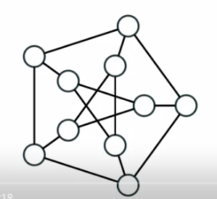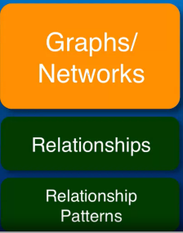

10 objects, 15 relations between them

Definition:

Formally Graph is pair of V and E

A Graph G = (V, E)

V – Set of objects/ Vertices/Nodes

E – set E of Edges

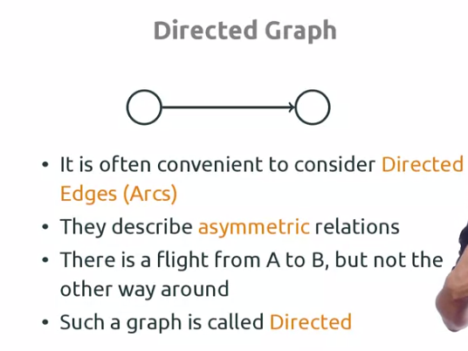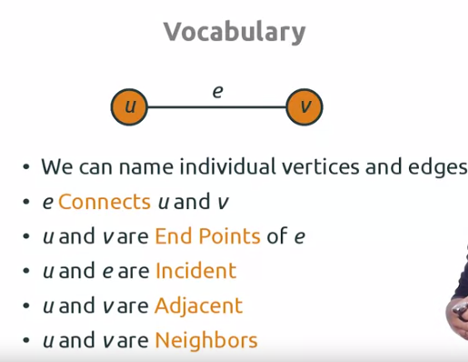

V and e are also incidents.

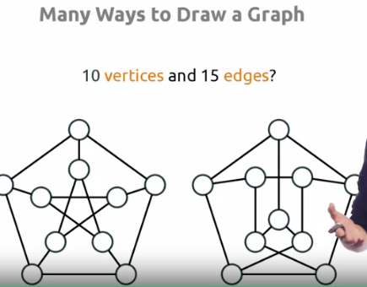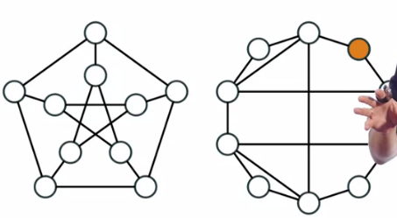

They are same because their neighbors are same. These are not same because their neighbors are not same.

**Why Graphs?**

Here are a few points that help you motivate to use graphs in your day-to-day [data science](https://courses.analyticsvidhya.com/courses/introduction-to-data-science-2?utm_source=blog&utm_medium=IntroductionGraphTheoryarticle) problems –

1. Graphs provide a better way of dealing with abstract concepts like relationships and interactions. They also offer an intuitively visual way of thinking about these concepts. Graphs also form a natural basis for analyzing relationships in a Social context
2. Graph Databases have become common computational tools and alternatives to SQL and NoSQL databases
3. Graphs are used to model analytics workflows in the form of DAGs (Directed acyclic graphs)
4. Some Neural Network Frameworks also use DAGs to model the various operations in different layers
5. Graph Theory concepts are used to study and model Social Networks, Fraud patterns, Power consumption patterns, Virality and Influence in social media. Social Network Analysis (SNA) is probably the best known application of Graph Theory for [Data Science](https://courses.analyticsvidhya.com/courses/introduction-to-data-science-2?utm_source=blog&utm_medium=IntroductionGraphTheoryarticle)
6. It is used in Clustering algorithms – Specifically K-Means
7. System Dynamics also uses some Graph Theory concepts – Specifically loops
8. Path Optimization is a subset of the Optimization problem that also uses Graph concepts
9. From a Computer Science perspective – Graphs offer computational efficiency. The Big O complexity for some algorithms is better for data arranged in the form of Graphs (compared to tabular data)

**Terminology you should know**

Before you go any further into the article, it is recommended that you should get familiar with these terminologies.

1. The vertices u and v are called the end vertices of the edge (u,v)
2. If two edges have the same end vertices they are Parallel
3. An edge of the form (v,v) is a loop
4. A Graph is simple if it has **no parallel edges and loops**
5. A Graph is said to be Empty if it has **no edges**. Meaning E is empty
6. A Graph is a Null Graph if it has **no vertices**. Meaning V and E is empty
7. A Graph with only **1 Vertex** is a Trivial graph
8. **Edges** are Adjacent if they have a common vertex. **Vertices** are Adjacent if they have a common edge
9. The **degree** of the vertex v, written as d(v), is the number of **edges** with v as an end vertex. By convention, we count a loop twice and parallel edges contribute separately
10. **Isolated Vertices** are vertices with degree 1. d(1) vertices are isolated
11. A Graph is **Complete** if its edge set contains every possible edge between ALL of the vertices
12. A Walk in a Graph G = (V,E) is a finite, alternating sequence of the form ViEi consisting of vertices and edges of the graph G
13. A Walk is Open if the initial and final vertices are different. A Walk is Closed if the initial and final vertices are the same
14. A Walk is a Trail if ANY edge is traversed atmost once.
15. A Trail is a Path if ANY vertex is traversed atmost once (Except for a closed walk)
16. A Closed Path is a Circuit – Analogous to electrical circuits

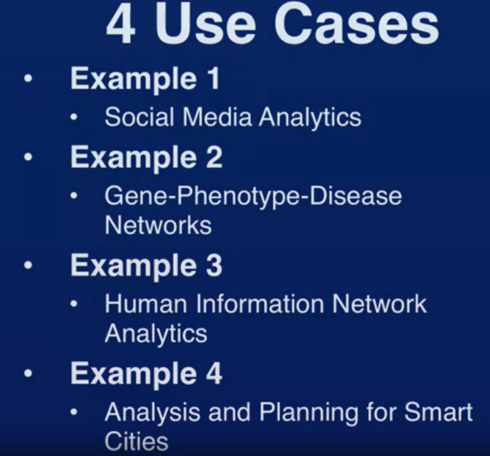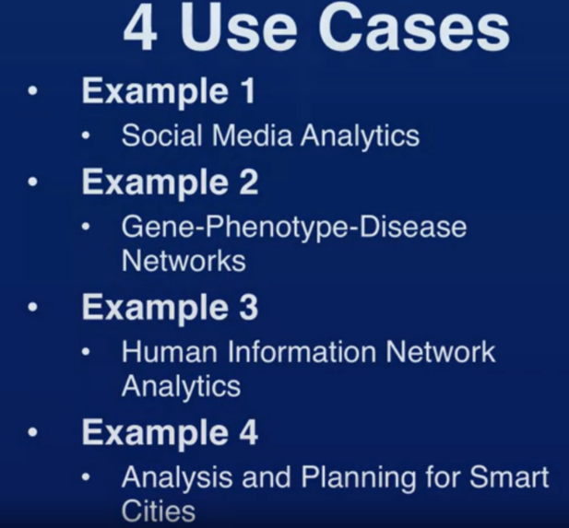

**Usecase-1**

**Social Media Networks**

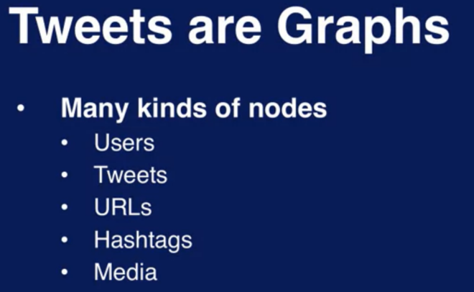

What about relationships??

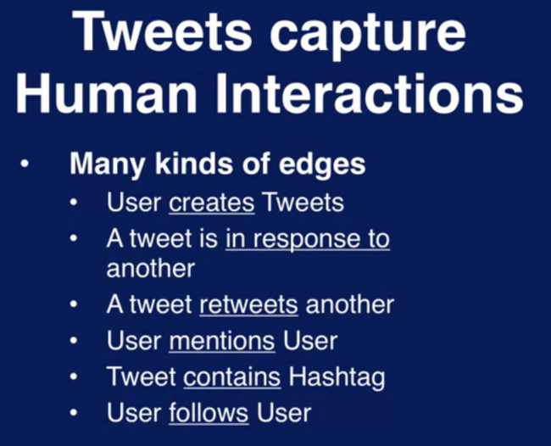

Example:

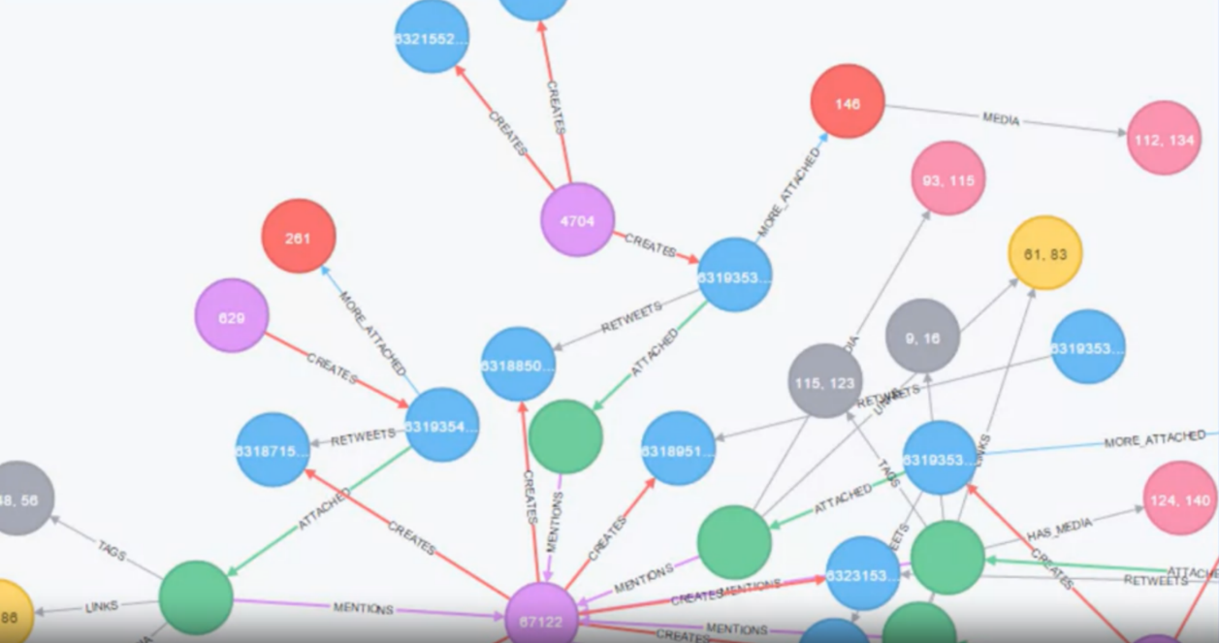

1. Light blue nodes are tweets
2. Purple nodes are users
3. Edge is created as a result of tweet something

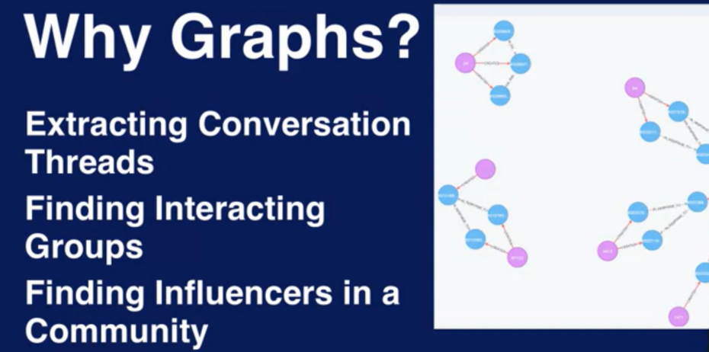

Who are the users that everybody refers to, listens to (influential users?)

**Usecase-2**

**Biology (Biological Networks)**

Interactions arise naturally in biology. Gene produce protein. Protein regulates the functions of other proteins. Cells transmit the signals to other signals. Etc.,

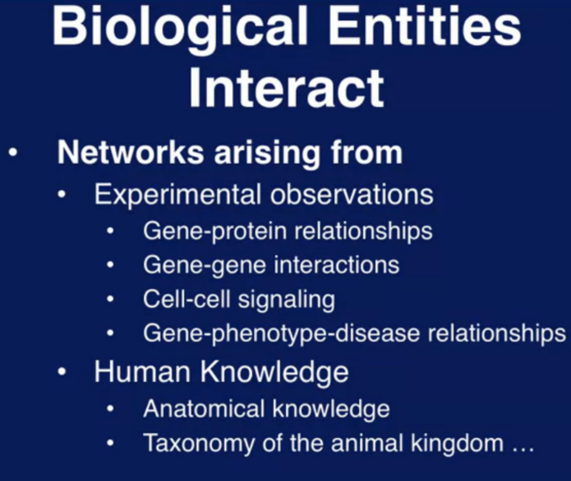

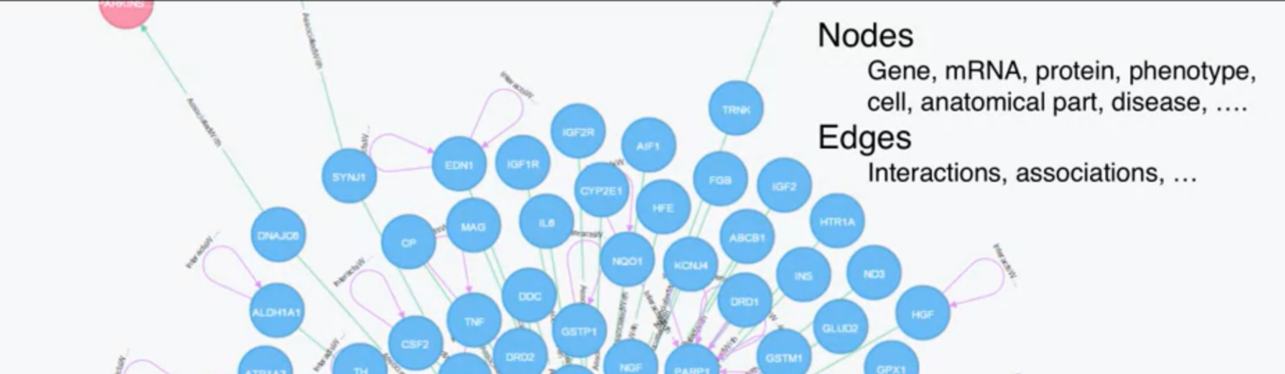

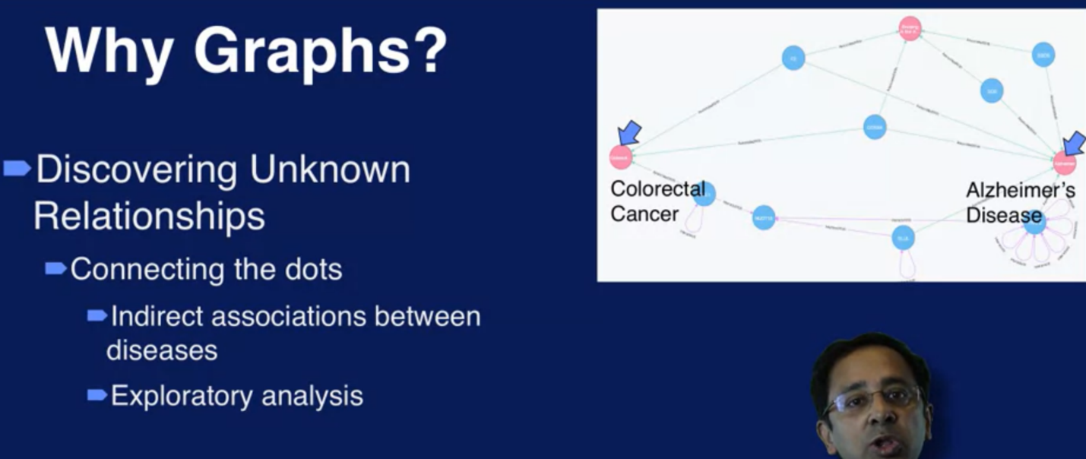

**Usecase-3**

**Human information network Analytics**

Everybody in LinkedIn are NODES. If they know each other EDGE between them is represented.

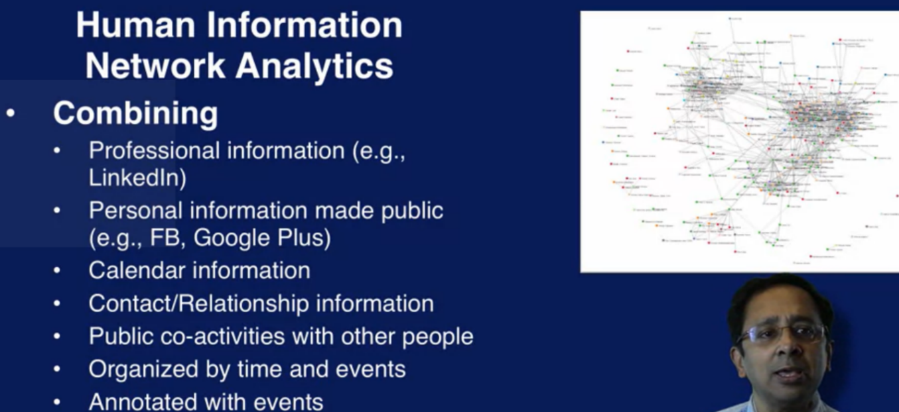

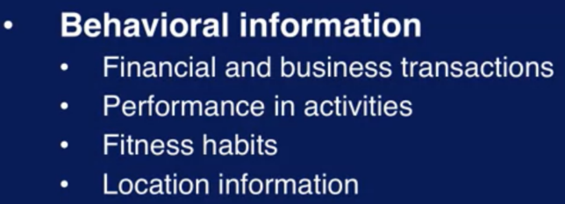

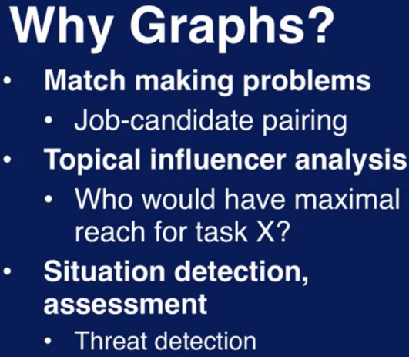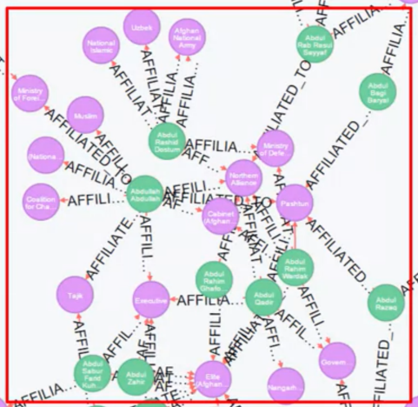

Green nodes are the Groups. Pink nodes are the named individuals

Some of these groups and individuals are more closely associated than others. Tracking and discovering these groups together with analysis of details of the events that they are associated with might help the analyst to get deeper understanding and anticipate their future activities.

**Usecase-4**

**Smart Cities**

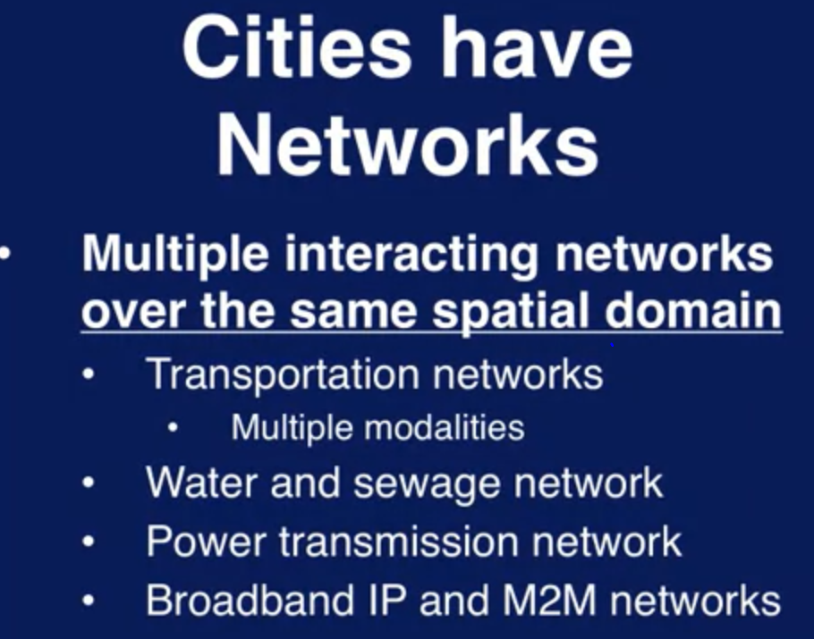

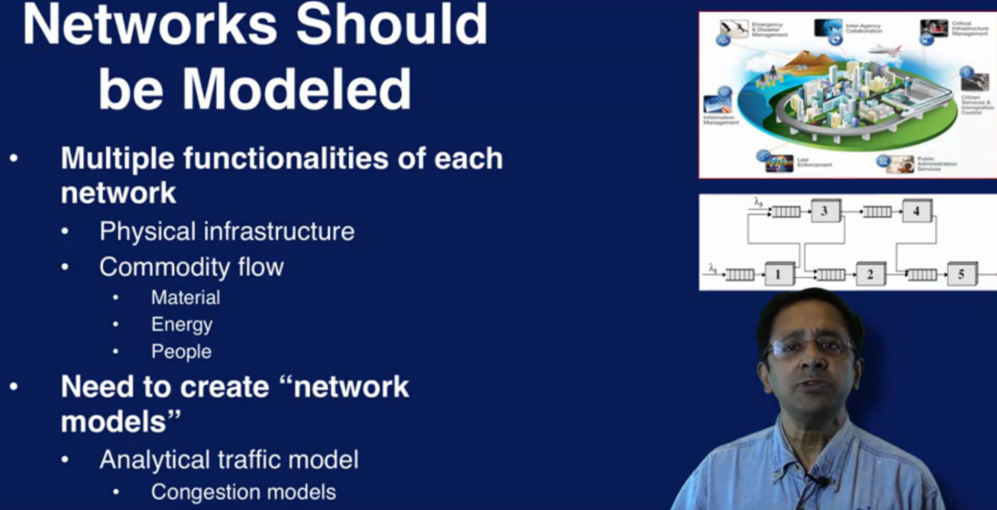

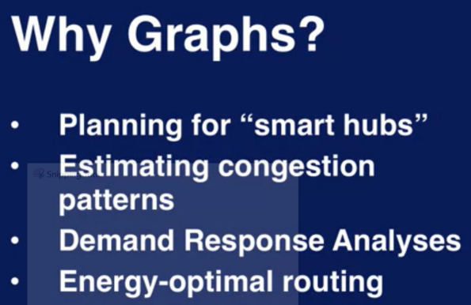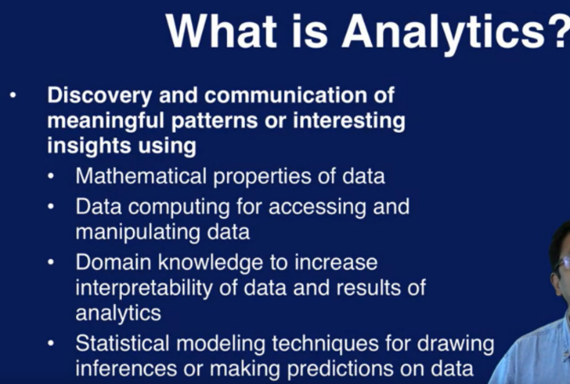

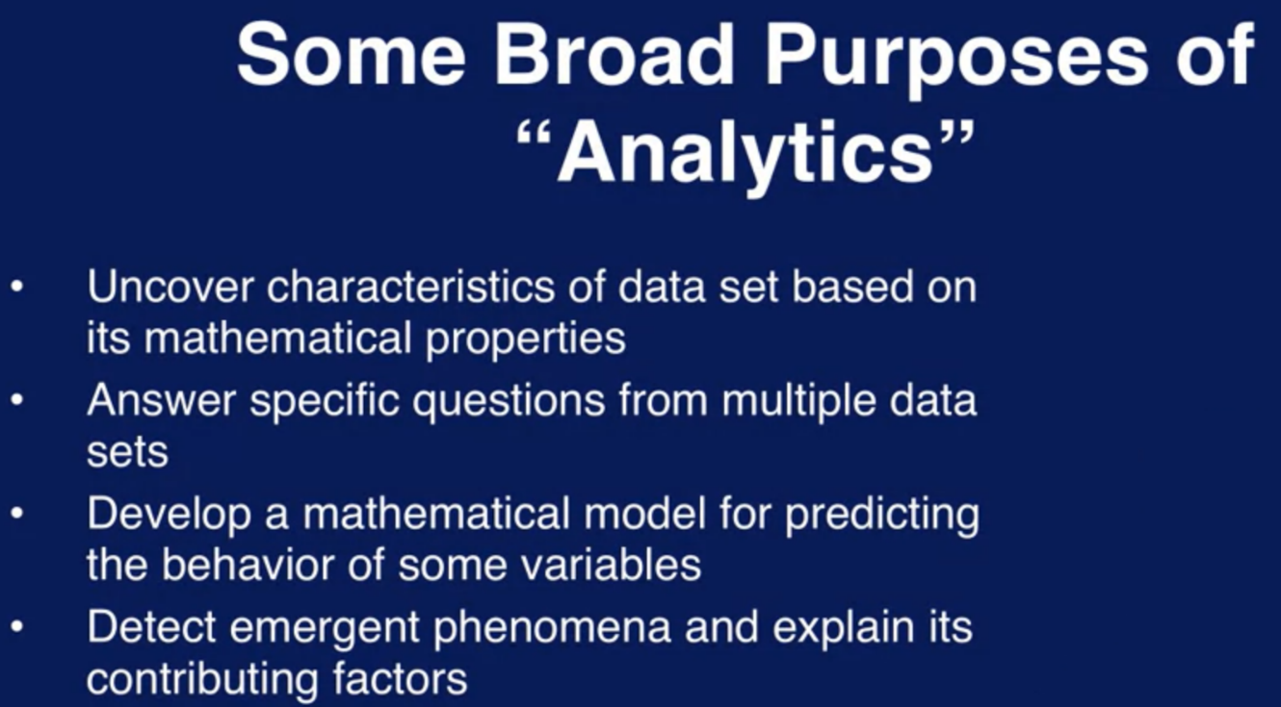

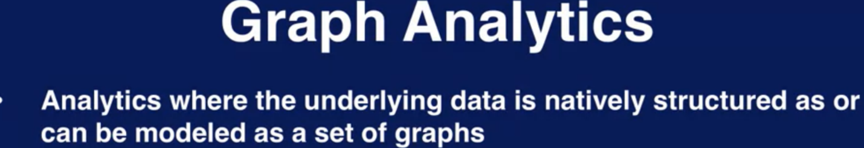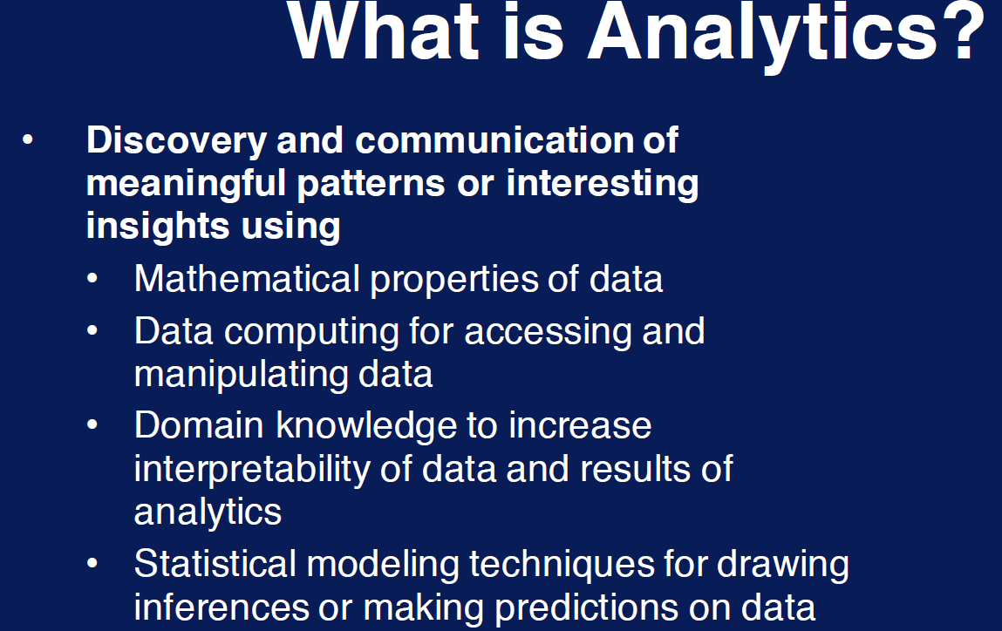

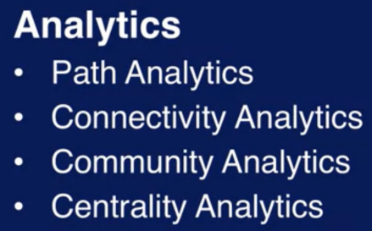

# **Node types:**

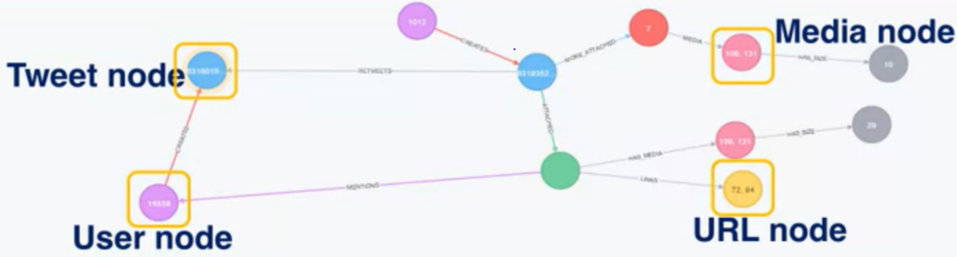

* **V: Set of vertices**
* **E: Set of edges**
* **TN: A set of node types**
* **F(TN--> V): Mapping function that assigns types to nodes**

In addition to node types, nodes also have attributes with values. Ex: Text is the name of the attribute that refers to textual body of the Tweet. (NODE text: “I like the post of ramu”)

This collection of attributes is called “Node Schema”). Similarly, Edge Schema

Interaction type is an attribute. This set of possible values such as Physical, genetic, biochemical etc., is called domain of the attribute (Modality of interaction between genes in Biochemical activity)

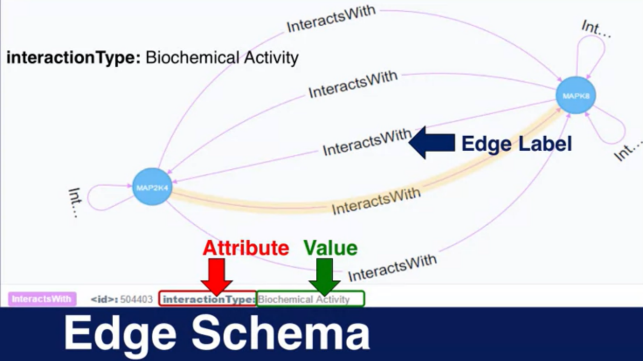

* TE: set of edge types
* G(TE-->E): type assignments to edges
* AN: Set of node attributes
* AE: Set of edge attributes

1. First task in graph analytics is to determine the informational models of the graph your application needs (Like above)

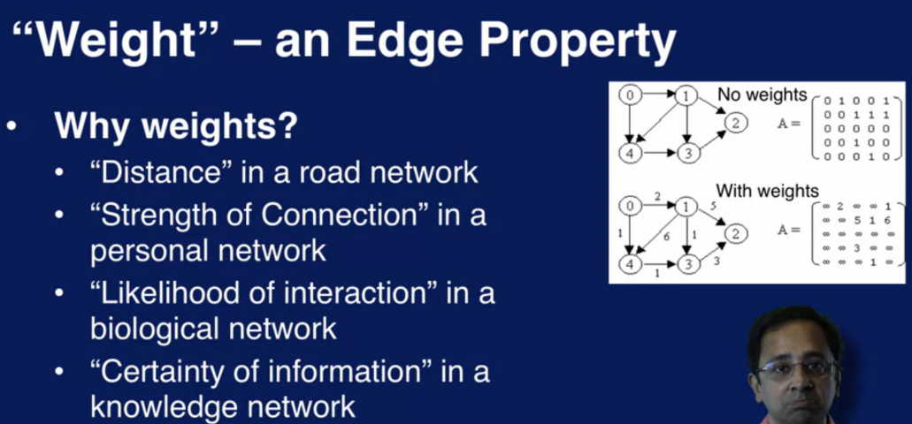

1. Structural property of a graph. Often contain valuable insights to a graph

Loop structure: Head and tail of the edge are on the same node. Can be informative for some applications

Multi-graph: Occurrence of multiple edges between the same node pair is called multi-Graph. Each edge will have different content information.

**Path Analytics:**

Walk: A walk in the graph, H-->B. Notice we have crossed F twice.

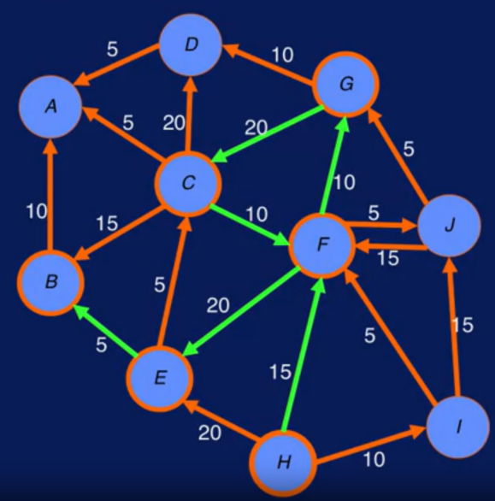

**Path:** Consider a walk where we do not repeat the nodes. Such a constrained path is known as “path”

**Cycle:** A path of length n>=3 whose start and end vertices are same.

**Acyclic:** Graph with no cycles.

**Deck:** Directed acyclic

**Trail:** A walk with no repeating edges.

**Reachability:** “I” is not reachable from A. No outgoing edge from A at all.

**Diameter of Graph:** Maximum number of steps or hops, one has to go the most distant node of the graph.

Example: If it can’t reach by any means--> oo(infinity)

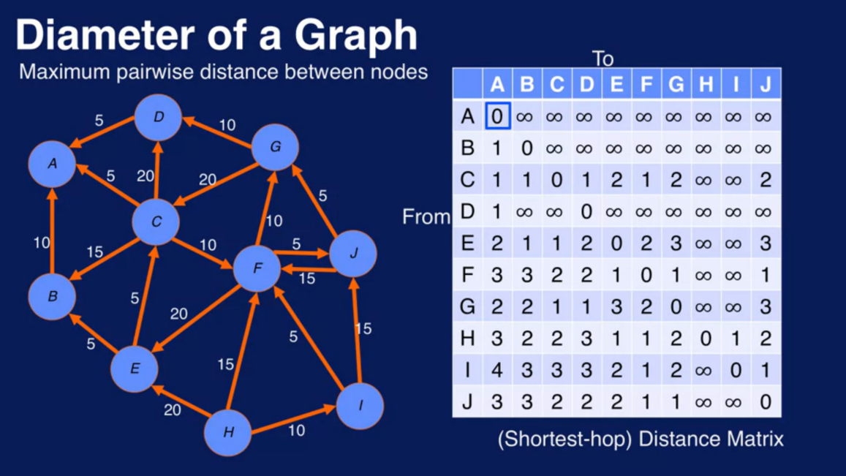

4 is the largest value in the matrix, thus, the diameter of the graph is 4.

**Basic path analytics question: What is the best path to go from 1 to 2?**

When one path is better than others.

This is an optimization problem subjected to constrains. What nodes to be included in the path and what nodes are not. Otherwise find least weight path from I to B.

**Applying “Dijkstra’s Algorithm”**

Start from node “i” and progressively traverse sequence of nodes. When a method attempts to choose the next node to traverse to, it chooses a node for which the total weight of the path to that node is the lowest.

**Connectivity Analytics**

**Two important graph analytics questions**

How robust is the graph?

How easy it is to break the graph by removing a few nodes and edges?

How similar is the structure of the graph G1 to graph G2?

What are some computable “features” that can describe the structure of a graph?

How can two graphs be compared based on these features?

Parameters by which we can compare them

**Connectedness:**

A graph is connected if it contains a directed path from u and v or directed path from v to u for every vertex pair (u, v). In a graph, if reach from any node to any other node. From the example below: Graph is not connected. However, we can define four parts of the graph that are themselves connected. These islands of connected parts are called components or connected components of a graph.

**Strongly connected**

For directed graphs, we say graphs are strongly connected, if we fallow the direction of edges and still reach every node from every other node.

**Weakly connected**

Connected after converting a directed graph to an undirected graph. Undirected version of graph is connected, this is called weakly connected

**Disconnecting a graph:**

Identifying the smallest set of nodes, if removed will disconnect the graph.

* Node based

If we remove F and D and H

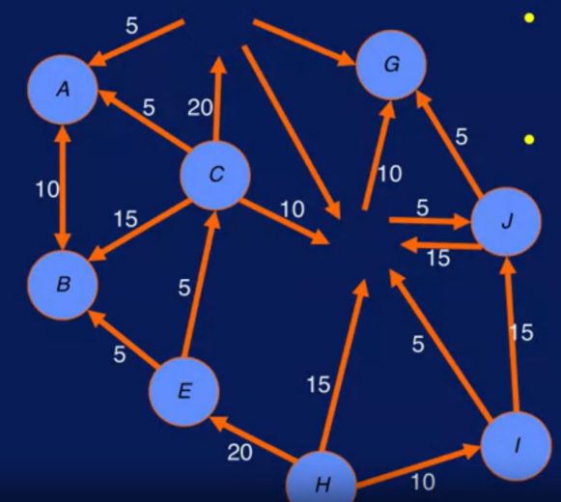

We have disconnected the graph. So, the connectivity is 3

* Edge based

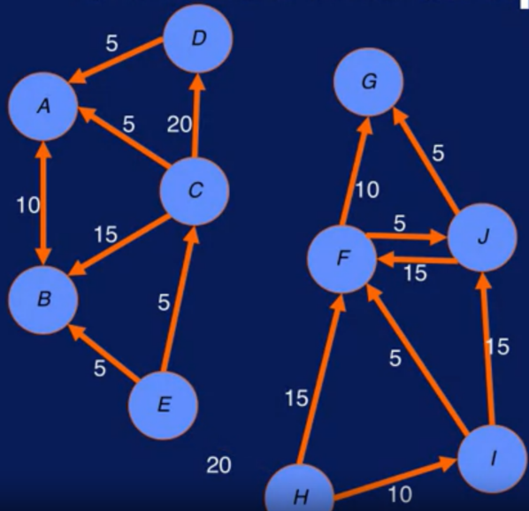

Edge connectivity is 4

**Network robustness**

If node V is reachable from node v originally, it should remain reachable even if the network is attached (node/edge removed)

IF you remove F. 5 paths are going to be disrupted. Higher degree nodes make the network more vulnerable.

**Community analytics**

Is about identifying and tracking groups of interacting entities in a network. We call these groups communities. Entities often interact within groups. Interactions form clusters

**Community**: A dense subgraph(cluster) within a group whose nodes are more connected within the cluster than to nodes outside the cluster.

**Analytic Questions**

**Static**—Analytic questions that do not depends on time are static.

What are communities at time T?

Who belongs to a community?

How closely knit in this community?

**Temporal/Evolution analysis –**

How did this community form?

Which communities are stable?

Find strong transient communities – why did they form/dissolve?

**Predictive Analysis—**

Is this community likely to grow?

Will these nodes continue as a community in the future?

Are dominant roles emerging in this community?

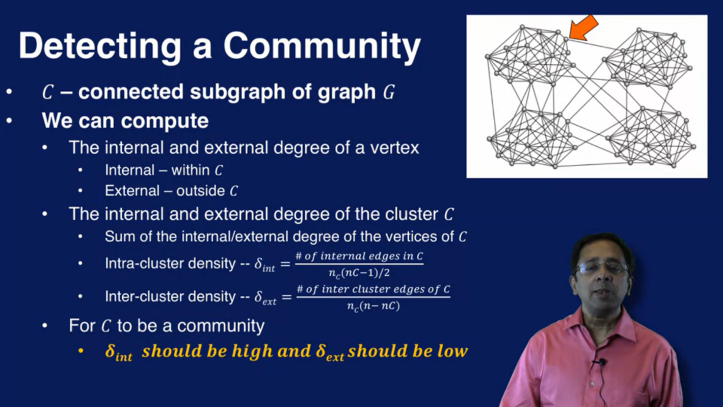

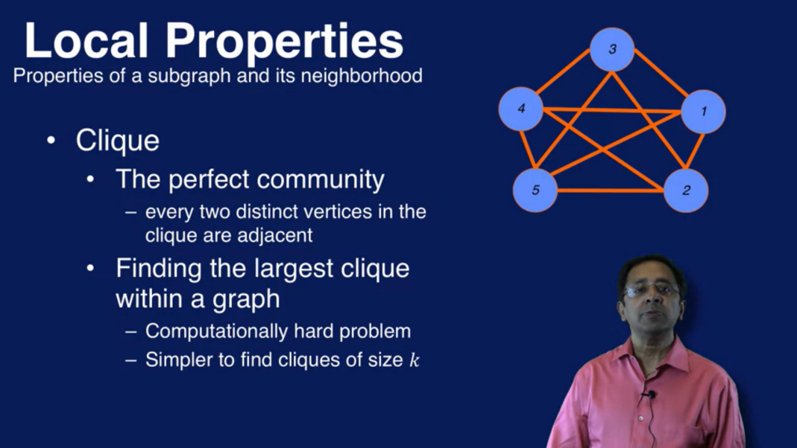

Local properties—

Clique, clack core

Global property—

Modularity: (-0.5 to 1)

It tries to estimate the quality of the clusters of communities in Graph. If we consider edges in a group and tries to see whether it is different from what you would see if the edges were assigned randomly with some probability distribution. If there is a community, there will be more edges than would happen at random.

If there is NO community, the number of edges in that part, either will be close to random or even lower than that.

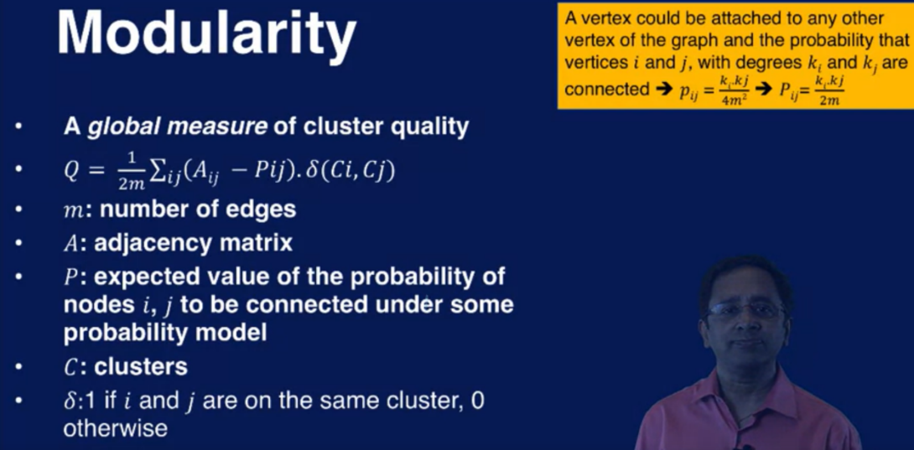

An algorithm that uses modularity is “Louvain” method community detection

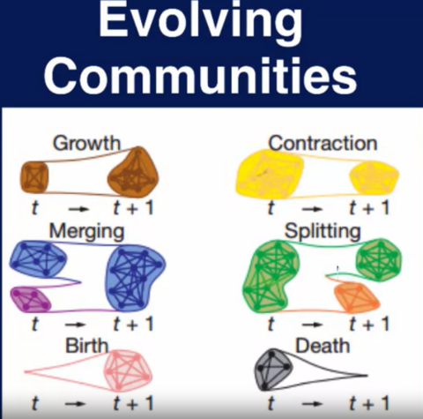

**Centrality analytics**

